10 years of Bikepark Serfaus-Fiss-Ladis
and other mountain bike must-dos and highlights
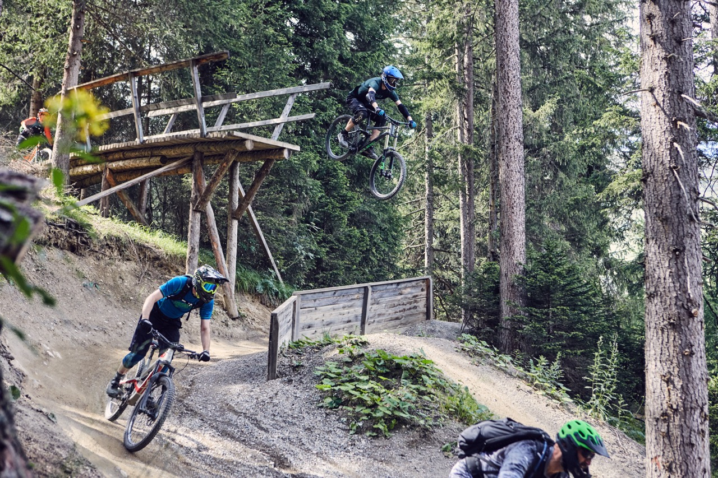
Serfaus-Fiss-Ladis, Austria – In the family-friendly Serfaus-Fiss-Ladis bike region, the joys of mountain biking extend far beyond summer. Although the temperatures might drop and the days might shorten, nature will show itself in the most beautiful colours on the high plateau in the Tyrolean Upper Inntal valley. The breath-taking landscapes provide the ideal canvas for your individual end of season mountain bike trip. So, there is no reason to mope. On the contrary: with the Bikepark Serfaus-Fiss-Ladis celebrating its 10th anniversary, everyone is in a party mood. In addition to the anniversary festival, there are several other highlights and must-dos that are definitely worth a visit in late summer and autumn.

10 years of Bikepark Serfaus-Fiss-Ladis – time to celebrate

The Bikepark Serfaus-Fiss-Ladis is celebrating its 10th anniversary. The big celebration will take place in Serfaus-Fiss-Ladis from 1 to 3 September with a festival including an expo area and free test opportunities on the event site, music by DJs, drinks and snacks in a well-rounded party atmosphere. You can also show off your own skills at various competitions. In addition, the Girls-Shred with mountain bike rider Bine Herzog will ensure that the female guests and riders do not miss out on the fun. So, you better show up because, after all, the bike park only turns ten once!

Of course, the best way to celebrate ten years of Bikepark Serfaus-Fiss-Ladis’ existence is with a few laps in the bike park itself, where year after year, guests are offered supreme mountain bike action. The nine lines, from very simple to very challenging, are available to all bike guests until 22 October. Whether you’re up for just a few fun lines or an all-out ride, the bike park has your back. When celebrating, toasting is a must, for which the huts, restaurants and cafés spread across the singletrack network and in the area around the bike park are ideal. For those who prefer to drop from huts rather than sitting within, the "Hill Bill" with its iconic Hut Drop is a hot tip.

Ultra-long, brand new singletrack action and a renowned highlight trail

With the brand new Zirbentrail, the Serfaus-Fiss-Ladis bike region has created a new singletrack highlight that combines everything that makes a mountain biker's heart beat faster. Starting at 2,600 metres above sea level, the incredible autumn panorama of the surrounding peaks can be admired from the Zwölferkopf summit before the fabulous 9.1 kilometres of singletrack descent is tackled. The mostly flowy trail contains many rollers, doubles, berms and North Shore elements offering pure variety for beginners and advanced riders. The Zirbentrail is based on three former trails (Almtrail, Flüstertrail, Zirbentrail), but also contains newly designed sections and features. The Zirbentrail also replaces the legendary Frommestrail (8.9 kilometres) as the longest singletrack in Serfaus-Fiss-Ladis.

Another absolute highlight trail is the Högtrail. Prized as one of the five Great Trails in Tyrol, that represent the best of the state’s more than 330 kilometres of singletracks, it must not be left out. A high flow can be expected on the 3.8-kilometer trail, while at the same time, jumps provide a little extra fun. North Shores and root sections are also characteristic of the Högtrail – a real "all-in-one" trail that is equally suitable for beginners and experienced singletrack riders alike.

If you want to experience even more singletrack action, you should definitely try the three other singletracks in the region.

Improving skills at the Women's and the Men's camps

In order to shred all singletracks and bike park lines or to make the mountain bike experience particularly unique, you need the necessary bike skills and techniques. At the Women's Camp and the Men's Camp, riders now have the opportunity to hone their basic technique and improve their bike handling. The idea is to work on the basics among like-minded people and with professional coaches, that teach you about choosing the best line, but also how to ride drops and tables, all in a relaxed atmosphere. The camps will take place from 8 to 10 September.

There is also a high-end selection of further courses for kids and teens as well as for adults in Serfaus-Fiss-Ladis.
Uphill challenge instead of downhill action?

BIKE EVEREST TIROL is an extraordinary mountain bike tour, that covers a whopping 8,848 metres in altitude. On this 285 kilometre tour, the height of Mount Everest is conquered by bike on seven stages that run between Garmisch-Partenkirchen (GER) and Nauders am Reschenpass (AUT). Stages five and six cross the Serfaus-Fiss-Ladis region. Individual participation is possible all year round. You can register for it here. BIKE EVEREST TIROL is a spectacular event for die-hard mountain bikers but also for more leisure-oriented e-bike fans, enchanting with an idyllic mountain backdrop and passing numerous historical sights. A diverse program is also provided for family members and friends who come along as companions and do not directly participate in BIKE EVEREST TIROL, such as regional leisure activities, excursions with the mountain railways and e-bikes rented locally and accompanying tours led by guides.

E-bike experience

If you have already been full-throttle all summer long or simply would like to take it easy, the best thing to do is simply grab an e-bike for a ride. With numerous long tours through the mountain bike region, there are hardly any limits in Serfaus-Fiss-Ladis. If you are longing for some adrenaline, the singletracks are always within reach. Sufficient charging stations and rest areas allow endless e-bike fun.

With the online tour planner, you can quickly and easily put together the perfect tour for your individual needs.

For more information on biking in Serfaus-Fiss-Ladis, visit: www.bike-sfl.at/en.
Details about the holiday region Serfaus-Fiss-Ladis can be found at: www.serfaus-fiss-ladis.at/en.
Find us on:

#serfausfissladis #wearefamily #weilwirsgeniessen
#bikesfl #bikeparksfl #bikeschulesfl #gooddaysfl #propain

REPRINT FREE OF CHARGE
COPY REQUESTED

Text and image download: www.bike-sfl.at/en/service/press

For media requests:

Serfaus-Fiss-Ladis Tourist Board
Alexandra Hangl
Gänsackerweg 2
6534 Serfaus, Austria
Phone: +43 (0)5476 6239 72
Email: a.hangl@serfaus-fiss-ladis.at

or
RASOULUTION GmbH
Philip Leidinger
Karl-Theodor-Straße 55
80803 Munich, Germany
Phone: +49 (0)89 386 67 09 17
Email: press@rasoulution.com

About the region Serfaus-Fiss-Ladis
Serfaus-Fiss-Ladis is the place to be for a family holiday. Regardless of whether it is summer or winter, there is always something going on. In summer cable cars and bus shuttles connect the mountainous region of Serfaus-Fiss-Ladis apart from many other attractions, the Serfaus-Fiss-Ladis high plateau offers bike fun for the whole family. From gentle bike rides for the whole family to mountain bike tours in the middle of breath-taking mountain scenery to action-packed descents on single trails or courses through Bikepark Serfaus-Fiss-Ladis, which celebrates its tenth anniversary this year. The Waldbahn takes riders and their bikes to the trails within the bike park, which have different levels of difficulty, from blue (easy) and red (medium) to black (expert). There is also a kid's park, slopestyle area with an air bag, pump track, dirt line and training area at the bottom station, where beginners can try out and get used to their new equipment. Experts in the bike shop advise on bike and safety equipment matters, and the bike school and rental office shop can also be found here. Besides the shop, there is also a chill-out area and a snack bar.

